Lab Assignment 2
Experiment 2: Exploring Additional AI Coding Tools beyond Copilot – Gemini (Colab) and Cursor AI

Name | Ganji Taneshwar
Enrollment No. | 2503A52719
Batch | 24
Course Code | 25CAI102PC205

Task 1: Statistical Summary for Survey Data

- Scenario:
You are a data analyst intern working with survey responses stored as numerical lists.

- Task:
Use Google Gemini in Colab to generate a Python function that reads a list of numbers and calculates the mean, minimum, and maximum values.

- Expected Output:
  - Correct Python function
  - Output shown in Colab
  - Screenshot of Gemini prompt and result

Output:
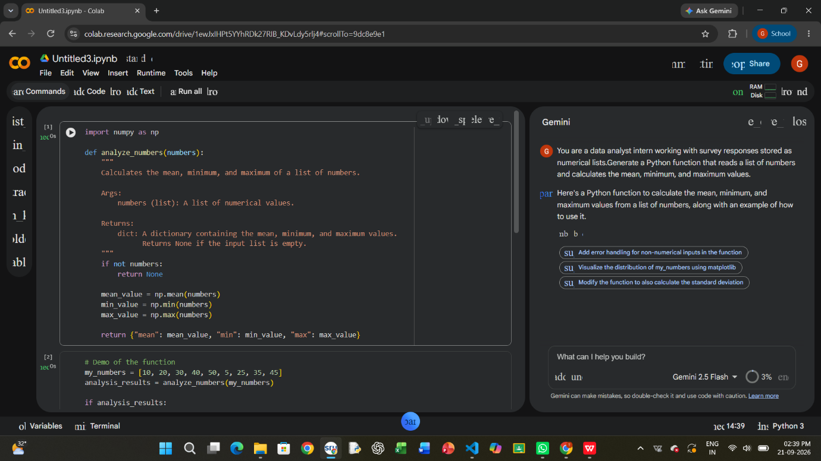
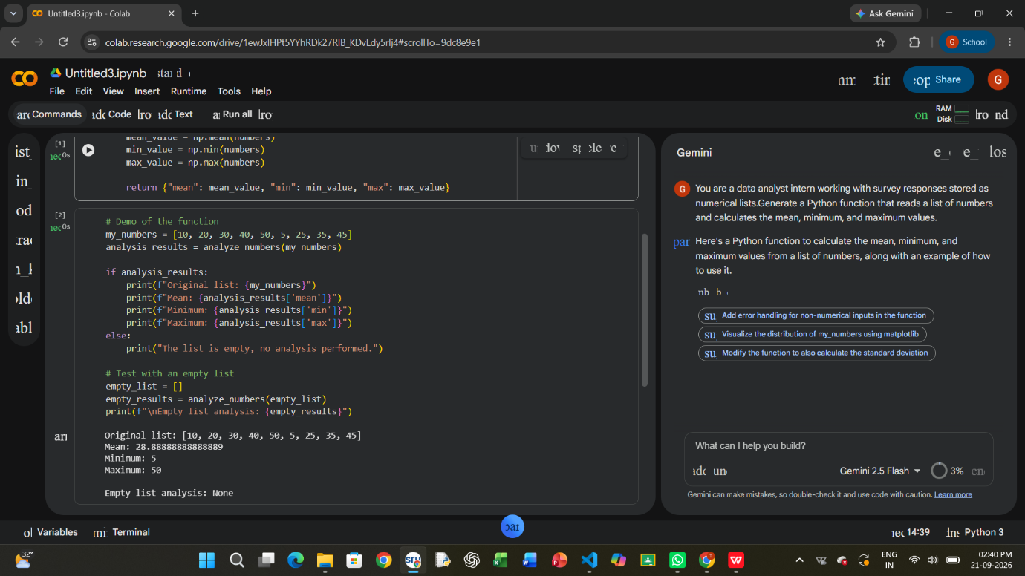
Task 2: Armstrong Number – AI Comparison

- Scenario:
You are evaluating AI tools for numeric validation logic.

- Task:
Generate an Armstrong number checker using Gemini and GitHub Copilot.
Compare their outputs, logic style, and clarity.

- Expected Output:
  - Side-by-side comparison table
  - Screenshots of prompts and generated code
Output:
Google Colab:
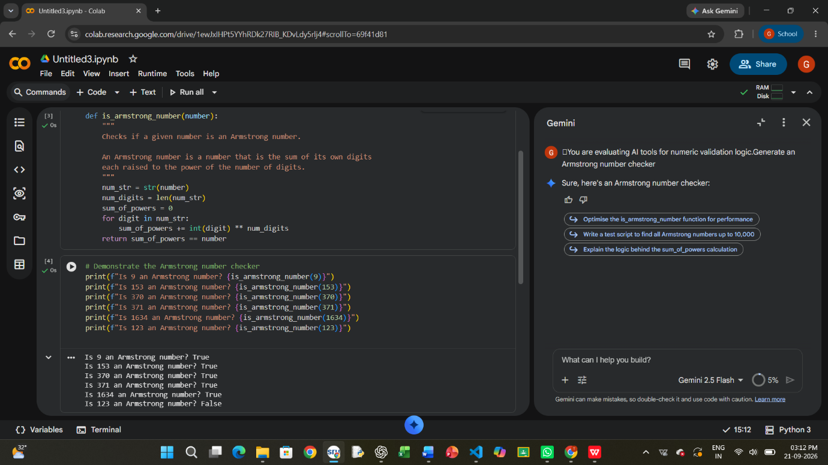
Git Hub Copilot:
Code:
#You are evaluating AI tools for numeric validation logic.Generate an Armstrong number checker
'''An Armstrong number (also known as a narcissistic number) is a number that is equal to the sum of its own digits raised to the power of the number of digits. For example, 153 is an Armstrong number because it has 3 digits and 1^3 + 5^3 + 3^3 = 153.
Here is a Python function that checks if a given number is an Armstrong number:'''
def is_armstrong_number(num):
"""Check if a number is an Armstrong number.

Args:
num (int): The number to check.

Returns:
bool: True if the number is an Armstrong number, False otherwise.

Example:
>>> is_armstrong_number(153)
True
>>> is_armstrong_number(123)
False
"""
# Convert the number to a string to easily iterate over digits
digits = str(num)
num_digits = len(digits)

# Calculate the sum of each digit raised to the power of the number of digits
armstrong_sum = sum(int(digit) ** num_digits for digit in digits)

# Check if the calculated sum is equal to the original number
return armstrong_sum == num
# Example usage:
print(is_armstrong_number(153)) # Output: True
print(is_armstrong_number(123)) # Output: False
print(is_armstrong_number(1652)) # Output: False
Output:
True
False
False
Task 3: Leap Year Validation Using Cursor AI

- Scenario:
You are validating a calendar module for a backend system.

- Task:
Use Cursor AI to generate a Python program that checks whether a given year is a leap year.
Use at least two different prompts and observe changes in code.

- Expected Output:
  - Two versions of code
  - Sample inputs/outputs
  - Brief comparison
Code:
def is_leap_year(year):
"""Check if a year is a leap year.

Args:
year (int): The year to check.
Returns:
bool: True if the year is a leap year, False otherwise.
Example:
>>> is_leap_year(2020)
True
>>> is_leap_year(1900)
False
>>> is_leap_year(2000)
True
"""
# A year is a leap year if it is divisible by 4
# but not divisible by 100, unless it is also divisible by 400.
if (year % 4 == 0 and year % 100 != 0) or (year % 400 == 0):
return True
else:
return False
# Example usage:
print(is_leap_year(2020)) # Output: True
print(is_leap_year(1900)) # Output: False
print(is_leap_year(2000)) # Output: True

Output:
True
False
True
Task 4: Student Logic + AI Refactoring (Odd/Even Sum)

- Scenario:
Company policy requires developers to write logic before using AI.

- Task:
Write a Python program that calculates the sum of odd and even numbers in a tuple, then refactor it using any AI tool.

- Expected Output:
  - Original code
  - Refactored code
  - Explanation of improvements
Code:
def sum_odd_even(numbers):
"""Calculate the sum of odd and even numbers in a tuple.

Args:
numbers (tuple): A tuple of integers.

Returns:
tuple: A tuple containing the sum of even numbers and the sum of odd numbers.

Example:
>>> sum_odd_even((1, 2, 3, 4, 5))
(6, 9)
"""
even_sum = sum(num for num in numbers if num % 2 == 0)
odd_sum = sum(num for num in numbers if num % 2 != 0)

return even_sum, odd_sum
# Example usage:
print(sum_odd_even((1, 2, 3, 4, 5))) # Output: (6, 9)
print(sum_odd_even((10, 15, 20, 25, 30))) # Output: (60, 40)
print(sum_odd_even((0, 1, 2, 3, 4, 5))) # Output: (6, 9)
Output:
(6, 9)
(60, 40)
(6, 9)

